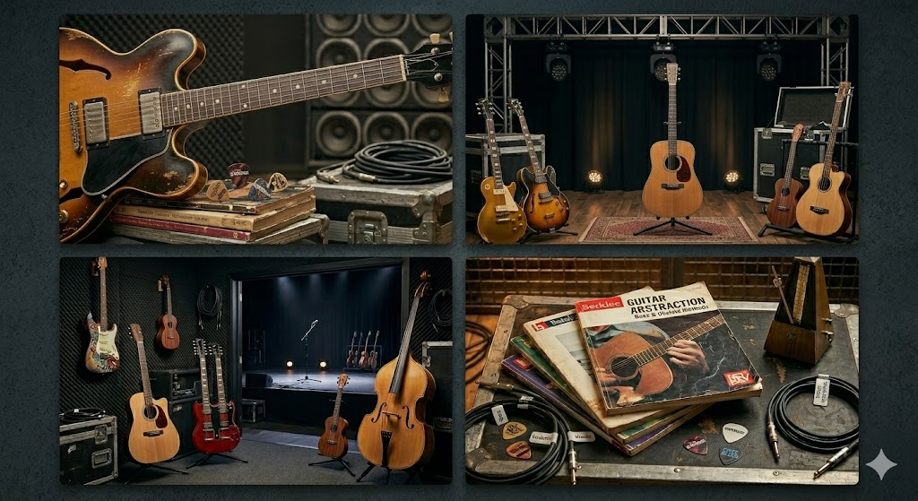 PROMO for John Parker

We would like to sincerely apologise for the recent interruption to our Guitar Program this term. We understand that consistency is extremely important for both students and families, and we appreciate your patience while we have been working to secure the right long-term replacement.
After a thorough search, we are very pleased to announce that the Guitar Program will be resuming under the direction of John Parker.
John is a highly respected guitar specialist with over 30 years of teaching experience across public and private schools, local music institutions, and the Education Department of Western Australia.
His background reflects not only longevity in the field but professionalism, reliability, and a strong educational foundation. John holds a current Working with Children Card and has a full police clearance.
Most importantly, John is committed to long-term involvement with our program. We have taken considerable care to ensure that this appointment provides the consistency and stability our families expect.
Lesson Structure
In addition to developing strong practical guitar technique, students will also be taught to read music and develop a solid understanding of music theory. This ensures well-rounded musical development rather than learning by imitation alone.
For students who wish to expand their experience further, opportunities to form small ensembles or bands can also be supported as the program grows.

